Course: CSE 204 – Computer Networks
LAB 8 – IPv6 Routing & FileZilla & Wireshark
Due date: June 11th, 2025

Student name | Nguyen Xuan Huan
Student ID | 2131200077

Goal
- Implementing IPv6 Routing
- Implementing File Transfer Protocol using FileZilla
- Ability to capture and analyze network packets using Wireshark

Assignment list
II.1. IPv6 Routing
Given a network as shown in the figure below.
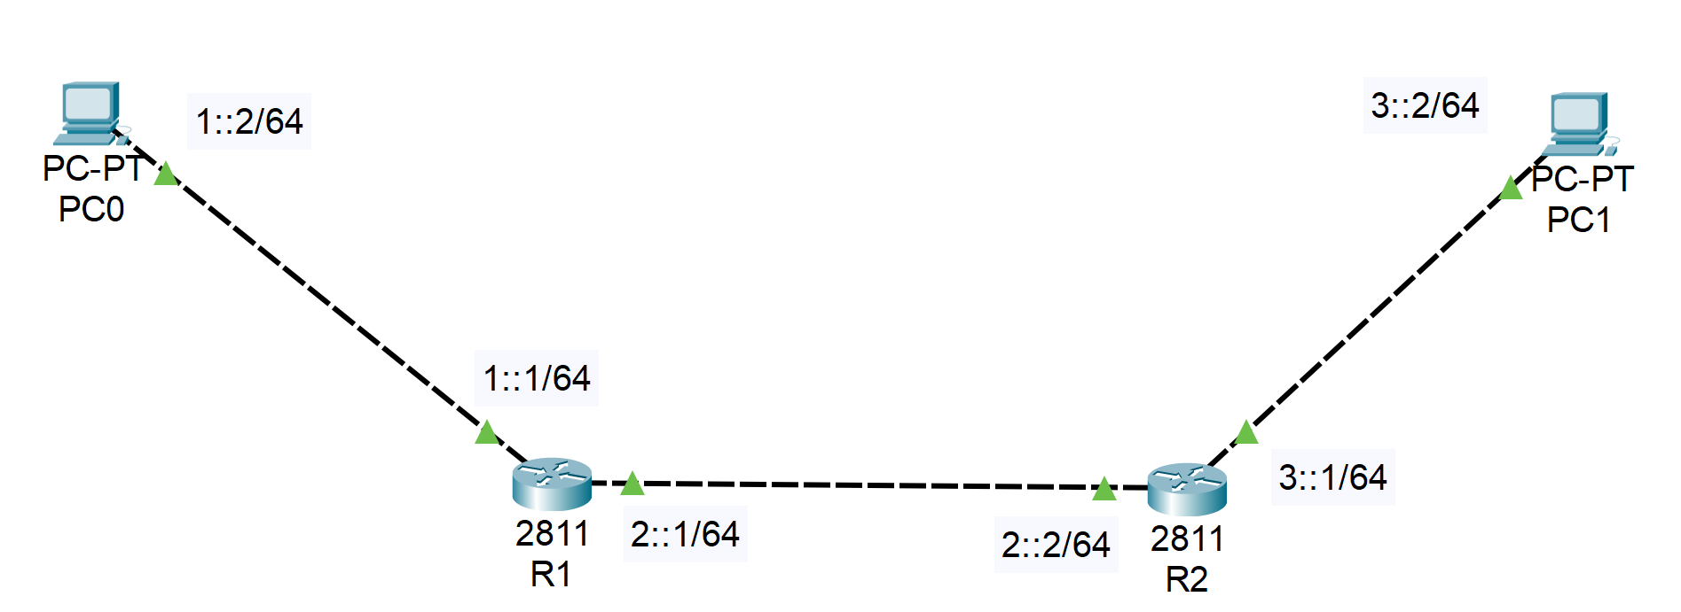
- On Router R1:
Router>enable
Router#config terminal
Router(config)#ipv6 unicast-routing
Router(config)#interface gigabitEthernet0/0
Router(config-if)#ipv6 address 1::1/64
Router(config-if)#no shut
Router(config-if)#exit
Router(config)#interface gigabitEthernet0/1
Router(config-if)#ipv6 address 2::1/64
Router(config-if)#no shut
Router(config-if)#exit
Router(config)#ipv6 route 3::/64 2::2

- On Router R2:
Router>enable
Router#config terminal
Router(config)#ipv6 unicast-routing
Router(config)#interface gigabitEthernet0/0
Router(config-if)#ipv6 address 3::1/64
Router(config-if)#no shut
Router(config-if)#exit
Router(config)#interface gigabitEthernet0/1
Router(config-if)#ipv6 address 2::2/64
Router(config-if)#no shut
Router(config-if)#exit
Router(config)#ipv6 route 1::/64 2::1

- Ping 2 PCs and show the result:
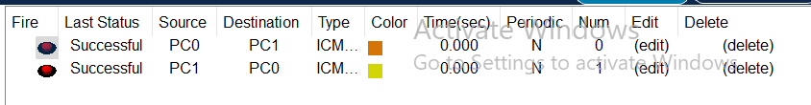
II.2. FileZilla Configuration
- Download FileZilla Server:
https://filezilla-project.org/download.php?platform=win64&type=server
- Download FileZilla Client:
https://filezilla-project.org/download.php?platform=win64
- Configure FileZilla Server:
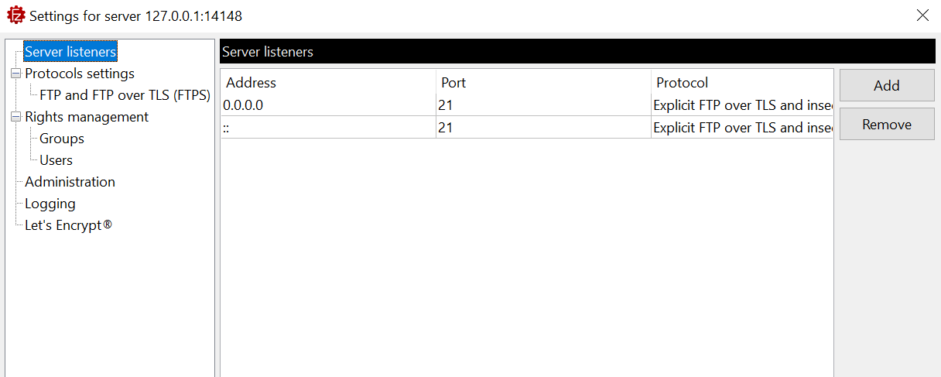
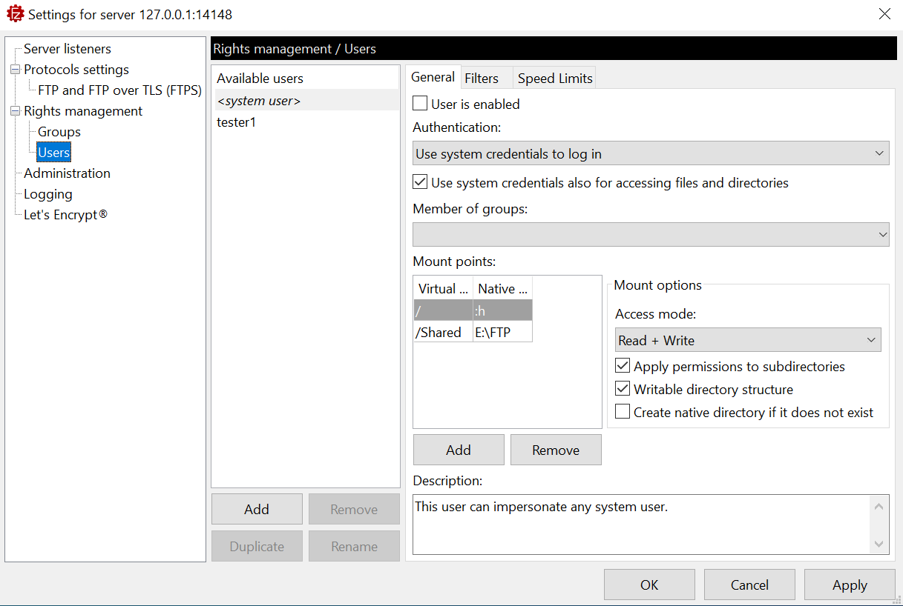
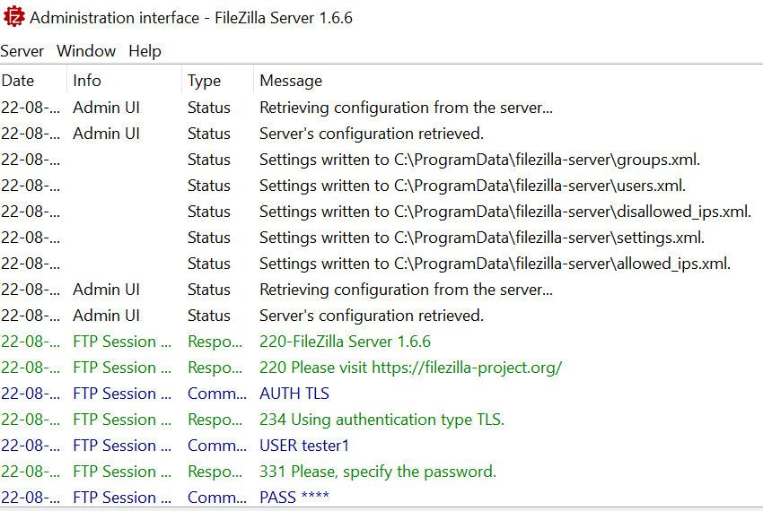
- Accessing to FileZilla Server using FileZilla Client:
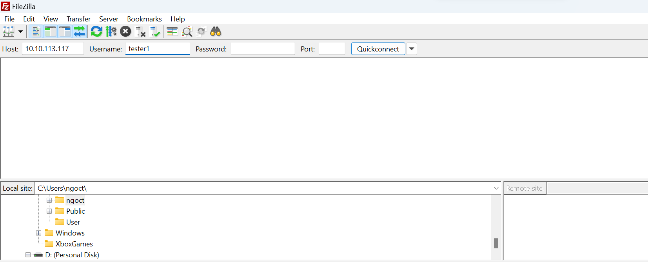
- Your result:
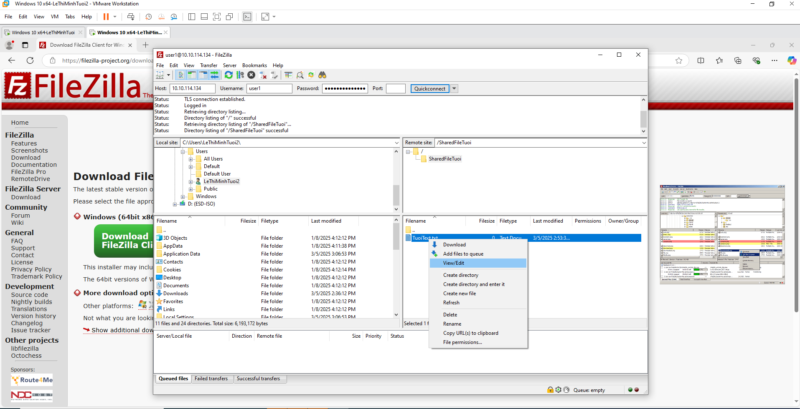
II.3. Wireshark
a) Wireshark Installation
- Follow the instructions to install Wireshark at: https://www.wireshark.org/
b) Using Wireshark
- To start to capture packets: At the main window, double-click on the Interface you want to capture the network traffic.
c) Wireshark Practice
- Start up the Wireshark packet sniffer
- Enter the following URL into your browser: http://gaia.cs.umass.edu/wireshark-labs/protected_pages/HTTP-wireshark-file5.html
- Type the user name and password. Then, click Sign in.
- Stop Wireshark packet capture, and enter “http” in the display-filter-specification window, so that only captured HTTP messages will be displayed in the packet-listing window.
- Question 1: Find the credential (user name, password) in the HTTP message.
Answer:
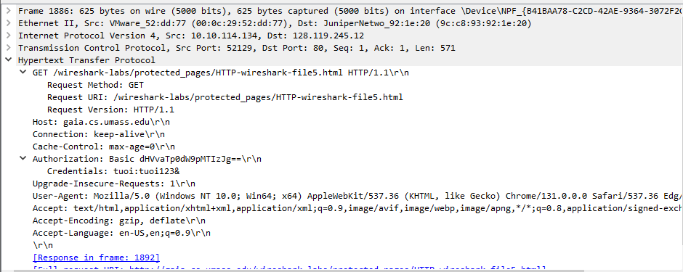
- Question 2: What is the server’s response (status code and phrase) in response to the initial HTTP GET message from your browser?
Answer:
d) Address Resolution Protocol
- Display the contents of the ARP cache on your computer using the command “arp –d –a”. What is the result of this command?
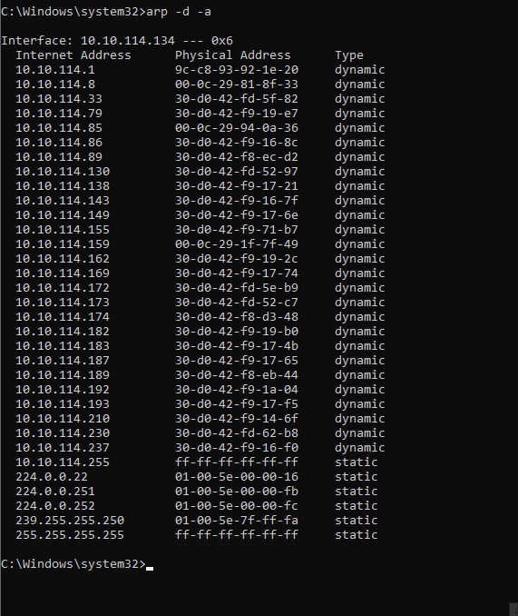
- Clear your ARP cache using the command “arp –d *” (make sure to open Command prompt using Administration privillege) and make sure your browser’s cache is cleared of previously downloaded documents. What is the result?
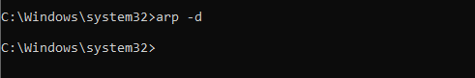
- Start the Wireshark packet sniffer.
- Enter the following URL into your browser: http://gaia.cs.umass.edu/wireshark-labs/HTTP-wireshark-lab-file3.html
- Your browser should again display the rather lengthy US Bill of Rights.
- Stop Wireshark packet capture
- Question 1: What is the hexadecimal value of the source address in the Ethernet frame containing the ARP request message sent out by your computer?
Answer:
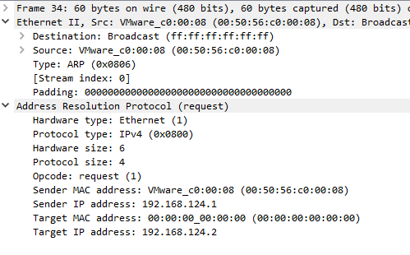
- Question 2: What is the hexadecimal value of the destination addresses in the Ethernet frame containing the ARP request message sent out by your computer?
Answer:

